**Incidence and Associated Outcomes of Acute Circulatory Support Prior to Heart Transplantation**

**Background**: Recent proposed changes to the UNOS allocation protocol prioritizes patients with acute circulatory support including extracorporeal membrane oxygenation (ECMO), percutaneous ventricular assist devices (PVAD), and intra-aortic balloon pump (IABP). We sought to evaluate contemporary trends in the incidence and associated outcomes of acute circulatory support during the hospitalization prior to heart transplantation.

**Methods**: From the Nationwide Inpatient Sample (NIS) from 1998 to 2011, we identified 5,381 patients who underwent orthotopic heart transplant (OHT) and determined whether the patient underwent pre-transplant ECMO, PVAD, or IABP. We calculated baseline characteristics and time trends in each subgroup.

**Results**: Of patients who underwent heart transplantation, 586 (10.9%) was supported by IABP, 110 (2.0%) was supported by PVAD, and 102 (1.9%) was supported by pre-transplantation ECMO. The utilization of PVAD prior to transplant has increased over time (p-value for trend = 0.002), while the total number of transplants and the utilization of IABP or ECMO has not changed over time (p-value for trend = 0.749, 0.803, 0.655 respectively). The rate of in-hospital mortality was significantly higher in patients with pre-transplant ECMO (11.8%), PVAD (14.5%), and IABP (18.1%) compared to patients without such acute circulatory support (4.1%, p < 0.001 for all comparisons). Patients who received acute circulatory support prior to transplant were older (48.7 vs. 46.1 years old, p < 0.001) and had a higher number of comorbid conditions (12.1 vs. 10.7 diagnoses, p < 0.001).

**Conclusions**: Pre-transplant acute circulatory support with IABP, PVAD, or ECMO represents a small subset of patients who undergo heart transplantation, however the utilization of PVAD has been increasing over time. These patients have increased in-hospital mortality, consistent with their increased age and number of comorbidities. Further study of the outcomes of acute circulatory support prior to transplant should be undertaken.

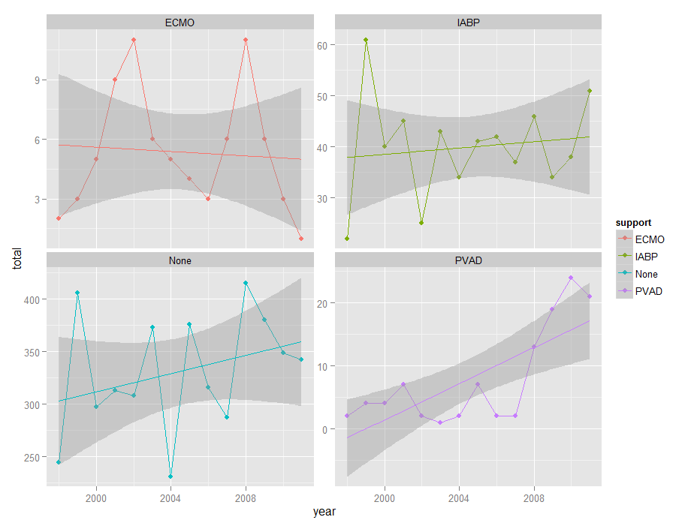

|  |  |  |  |  |  |
| --- | --- | --- | --- | --- | --- |
| Table 1. Baseline characteristics of patients who undergo heart transplantation subsetted by the utilization of acute circulatory support | | | | | |
|  | **None**  **n = 4637** | **IABP**  **n = 586** | **PVAD**  **n = 110** | **ECMO**  **n = 102** | **Total**  **n = 5381** |
| Length of stay, mean ± SD | 39.8 ± 48.4 | 56.4 ± 50.7 | 60.5 ± 56.8 | 88.5 ± 62.1 | 42.7 ± 498 |
| Mortality, n (%) | 223 (4.8) | 106 (18.1) | 16 (14.5) | 12 (11.8) | 350 (6.5) |
| Age, mean ± SD | 46.2 ± 18.9 | 51.6 ± 13.1 | 43.2 ± 21.4 | 37.4 ± 21.2 | 46.5 ± 18.6 |
| Sex, n (%) | | | | | |
| Male | 3370 (72.7) | 433 (73.9) | 83 (75.5) | 74 (72.5) | 3917 (72.8) |
| Female | 1266 (27.3) | 153 (24.5) | 27 (27.5) | 28 (27.5) | 1463 (27.2) |
| Race, n (%) | | | | | |
| White | 2638(56.9) | 325 (55.5) | 63 (57.3) | 57 (55.9) | 3050 (56.7) |
| Black | 587 (12.7) | 70 (11.9) | 22 (20.0) | 14 (13.7) | 680 (12.6) |
| Hispanic | 355 (7.7) | 39 (6.7) | 16 (14.5) | 15 (14.7) | 420 (7.8) |
| Asian/Pacific Islander | 109 (2.4) | 17 (2.9) | 4 (3.6) | 4 (3.9) | 133 (2.5) |
| Native American | 11 (0.2) | 5 (0.9) | 0 (0.0) | 0 (0.0) | 16 (0.3) |
| Other or unknown | 937 (18.5) | 130 (22.1) | 5 (3.8) | 12 (11.8) | 1082 (18.2) |
| Median household income, n (%) | | | | | |
| $1-24,999 | 735 (15.9) | 84 (14.3) | 26 (23.6) | 15 (14.7) | 850 (15.8) |
| $25,000-34,999 | 1074 (23.2) | 149 (25.4) | 27 (24.5) | 27 (26.5) | 1261 (23.4) |
| $35,000-44,999 | 1238 (26.7) | 142 (24.2) | 25 (22.7) | 27 (26.5) | 1419 (26.4) |
| $45,000 or more | 1463 (31.6) | 201 (34.3) | 30 (27.3) | 32 (32.4) | 1711 (31.8) |
| Unknown | 127 (2.7) | 10 (1.7) | 2 (1.8) | 1 (1.0) | 140 (2.6) |
| Comorbidities | | | | | |
| Diabetes | 870 (18.8) | 83 (14.2) | 19 (17.3) | 11 (10.8) | 977 (18.2) |
| Hyperlipidemia | 777 (16.8) | 42 (7.2) | 14 (12.7) | 9 (8.8) | 838 15.6) |
| Hypertension | 954 (20.6) | 69 (11.8) | 12 (10.9) | 8 (7.8) | 1039 (19.3) |
| History of smoking | 286 (6.2) | 20 (3.4) | 3 (2.7) | 4 (3.9) | 311 (5.8) |
| BMI ≥ 30 kg/m2 | 122 (2.6) | 10 (1.7) | 4 (3.6) | 2 (2.0) | 137 (2.5) |
|  |  |  |  |  |  |
| Number of comorbid diagnoses, mean ± SD | 10.7 ± 3.4 | 11.8 ± 3.0 | 13.9 ± 2.1 | 12.6 ± 3.0 | 10.86 ± 3.4 |

SD, Standard Deviation; BMI, Body Mass Index; ECMO, extracorporeal membrane oxygenation; PVAD, percutaneous ventricular assist devices; IABP, intra-aortic balloon pump.